Name: Cranston Wright III Personality Plus
Step 1: Who am I?
You will be using the chart on page 2 of this document to list these things. You might want to type them after each question below as you think about them.

What do I like to do? (Think about experiences you have enjoyed. What kind of school, religious, social or sports activities you like to do)

I like to play basketball, put things together, eat, sleep and play video games.

What are your talents, hobbies and/or abilities?

My talents are playing basketball and video games.

What do other people say you are good at doing?

I’m good at math playing sports and games and yard work.

What subjects at school do you like? What clubs or organizations do you belong to?

I like math and gym. I am in no clubs.

What do you like to do in your free time? (Have you volunteered, worked jobs in the neighborhood…)

In my free time I clean, play video games, play basketball, and eat.

Which skill areas describe you the best? Click these links and jot down (copy and paste) a few which describe you.

Mathematics: Use numbers, fractions, and percentages to solve problems; use tables, graphs, diagrams, and charts; use computer to enter, retrieve, change, and communicate numerical information.
Teamwork: Work cooperatively with others; contribute to group with ideas and effort; do own share of work; encourage team members; resolve differences for the benefit of the team; responsibly challenge existing procedures, policies, or authorities.
Responsibility: Work hard to reach goals, even if task is unpleasant; do quality work; display high standard of attendance, honesty, energy, and optimism.

Who Am I?
Things you like to do
(*like to do list)
Words that describe you
(see the *are you list)


Athletic
Energetic

Play Basketball
Play Video Games
Sleep
Eat

`

Hobbies
Things you can do
(*can do list)
Cranston Wright III

Play Basketball
Play Video Games
Yard Work
Constructing
Sleep
Eat
Basketball
Soccer
Football
Fishing
Workout

Personality Type (from Step 2 next page)

Realisitic

Step 2 options: Realistic (a Doer), Investigative (Thinker), Artistic (Creator), Social (Helper), Enterprising (Persuader), Conventional (Organizer)
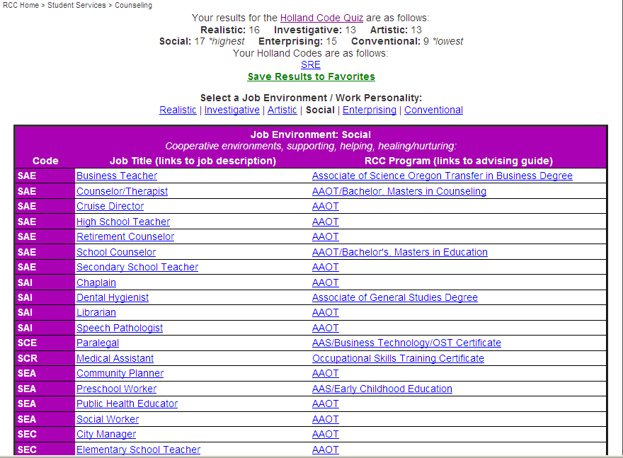

Step 2: Holland’s Code Quiz
Which type of personality are you? Click this link to take the quiz online (or download the paper version).
After taking the quiz, do a screenshot of the results. Draw an arrow to the section of the chart below that was your highest scoring area, and then type the name of it into the box in the chart provided in step 1.
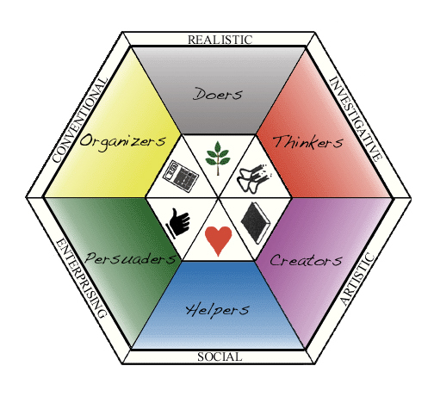
Which is marked *highest on yours?
Potential Careers
Example of a screenshot of one persons results: 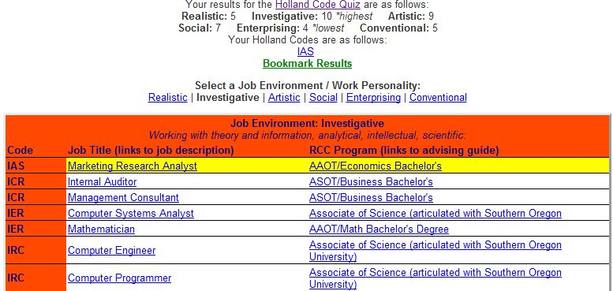
3 letter Holland Code
Clicking on the Job Title will take you to information about the median salary, required education, and Job outlook. *Some do not have this information available. Here is an example:
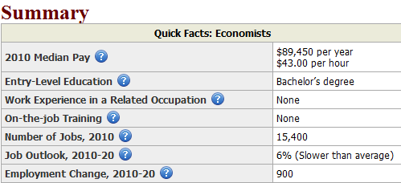

Step 3: Learn more about your Holland’s personality type. Click here
Look at the bulleted list of items which describe your personality type.
Alternative: You can refer to the following information:
- Realistic (this person is a Doer)
- Investigative (this person is a Thinker)
- Artistic (this person is a Creator)
- Social (this person is a Helper)
- Enterprising (this person is a Persuader), and
- Conventional (this person is an Organizer).

Copy and paste the words into a list that describes you below:
Practical, athletic, straightforward/frank, mechanically inclined, a nature lover, thrifty, curious about the physical world, stable concrete, reserved, self-controlled, independent, ambitious, systematic and persistent.

Step 4: Create a Personality Map
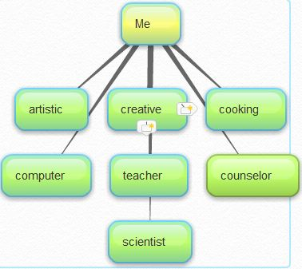
Create a graphic illustration of what you have learned from this activity. Take 10 or more words which best describe your personality and interests and create a graphic illustration, save and paste it below.
Tools we suggest:
Bubbl.us and create a mind map (example shown here)

Use a Word Cloud such as Wordle (example below)
 or a similar one from Tagzedo


